**Jumbled killer**

**(a small demon thought)**

Presented by,

Tharun panday.b

(13167)

CSE

**Thanks to:**

**Dr.A.PASUMPONPANDIAN**

**Prof.NR.RAJALAKSHMI**

**Step 1:**

* Designing the forms:
* 10 forms are designed here.
* Each one has its own :
* Background,
* Text boxes,
* Labels,
* Buttons.

Screen shot of Designed Form

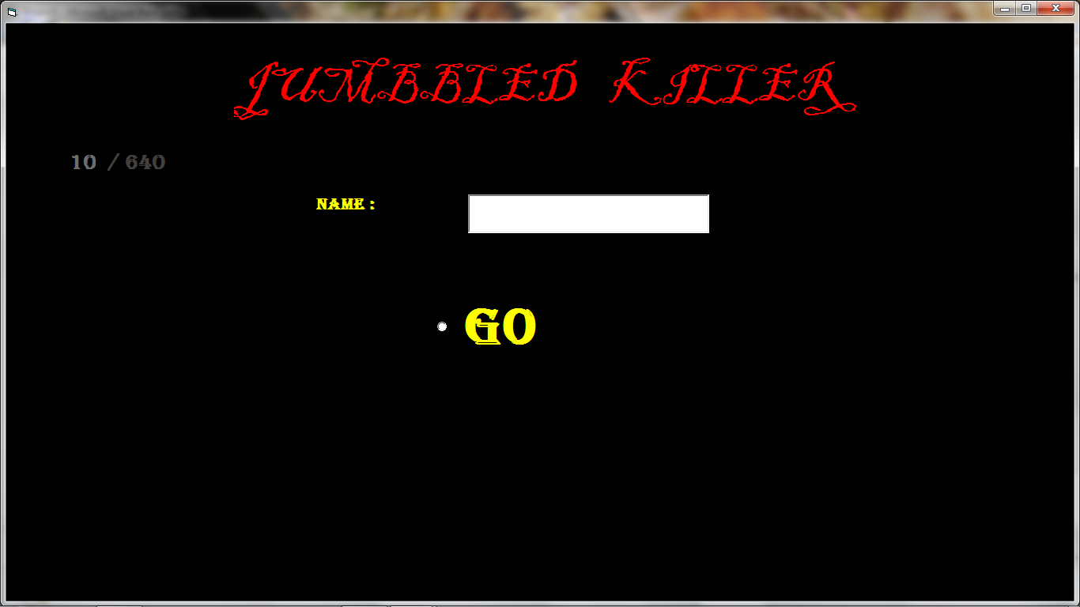

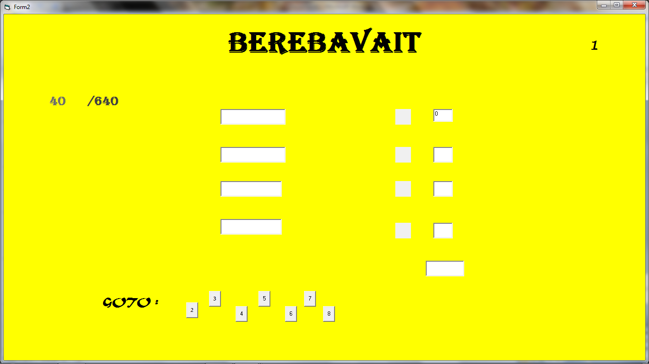

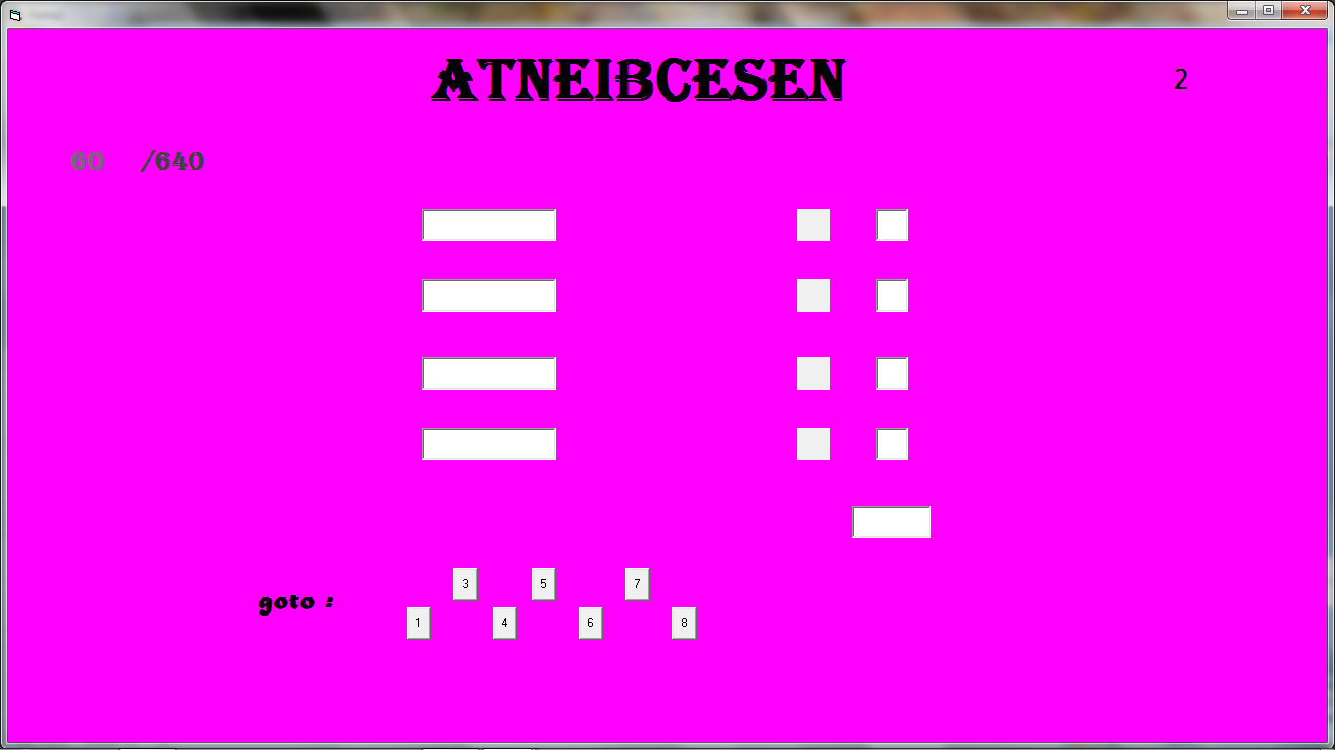

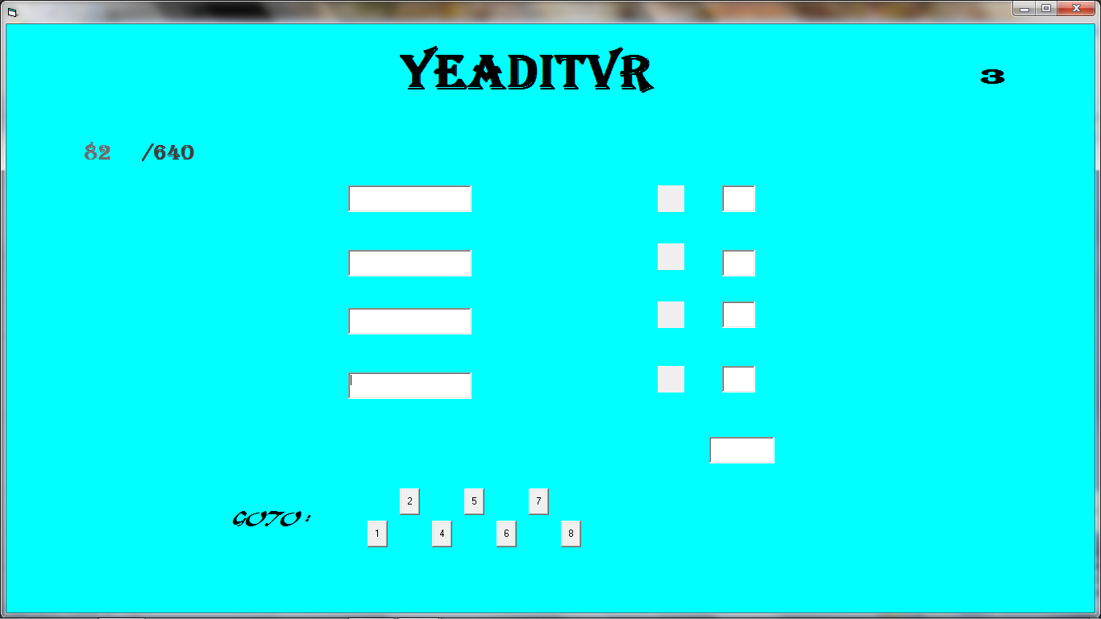

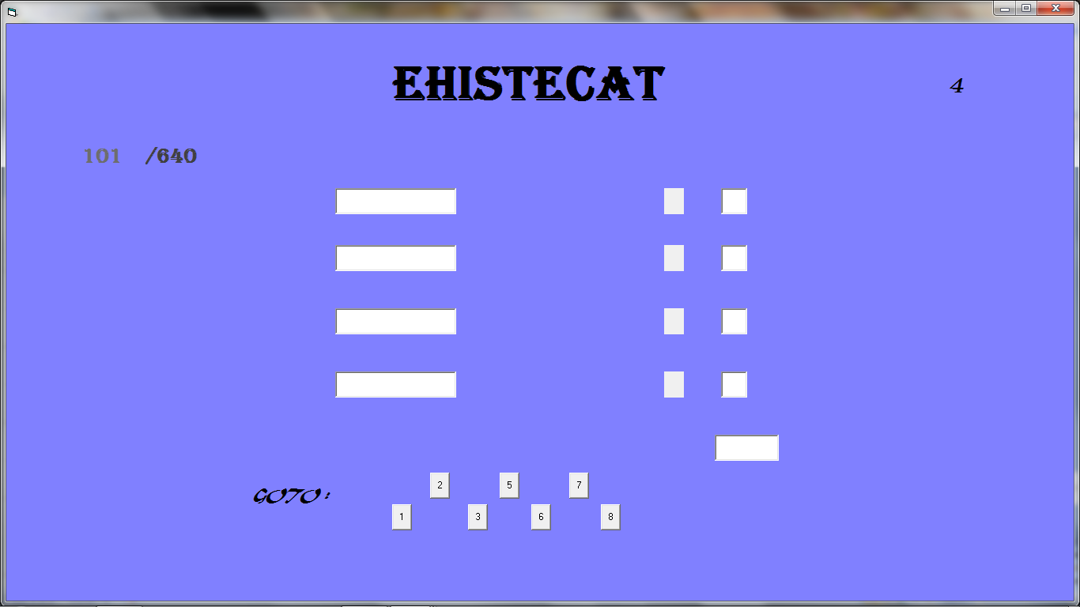

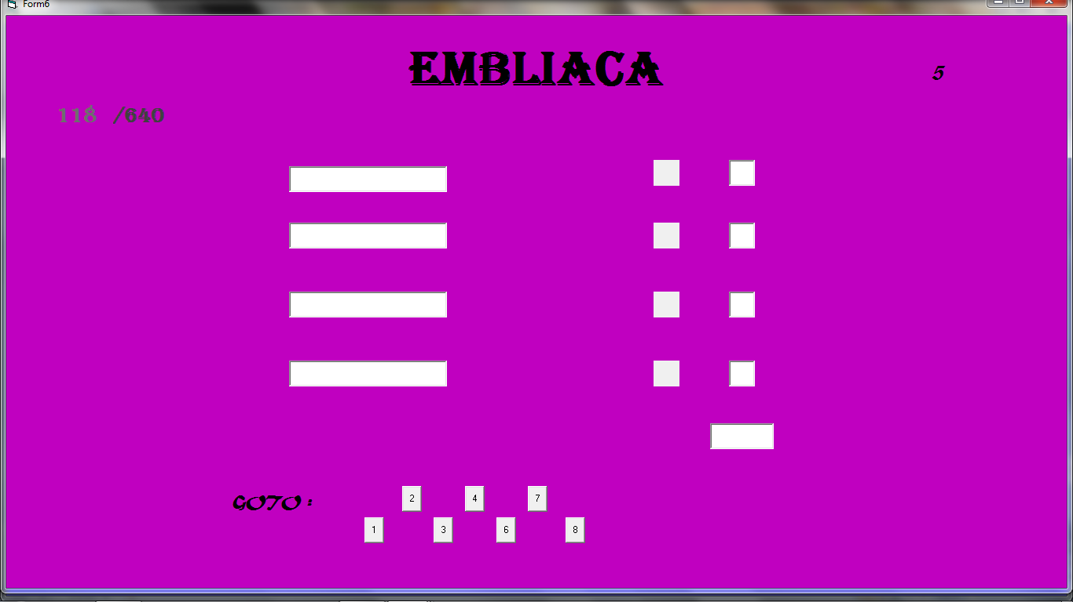

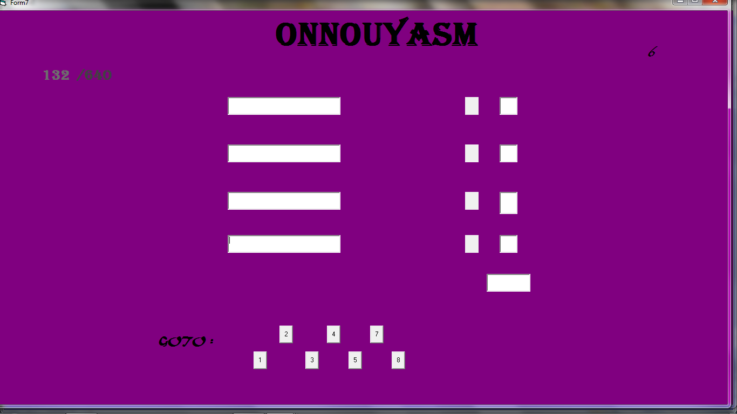

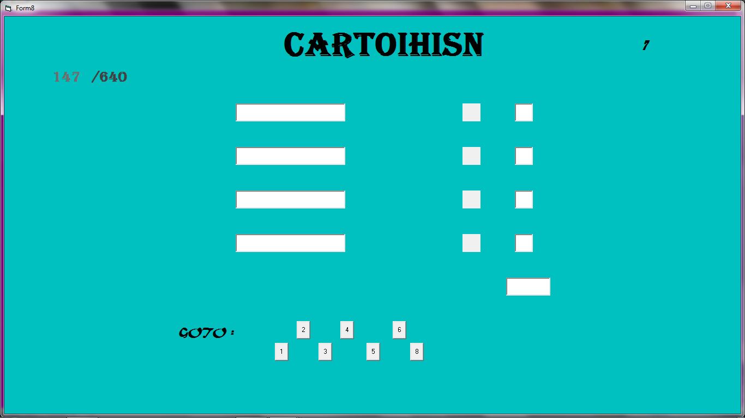

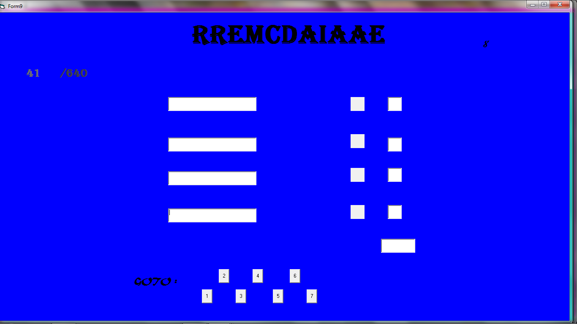

* **Step 2:**
* codes of **Jumbled killer**

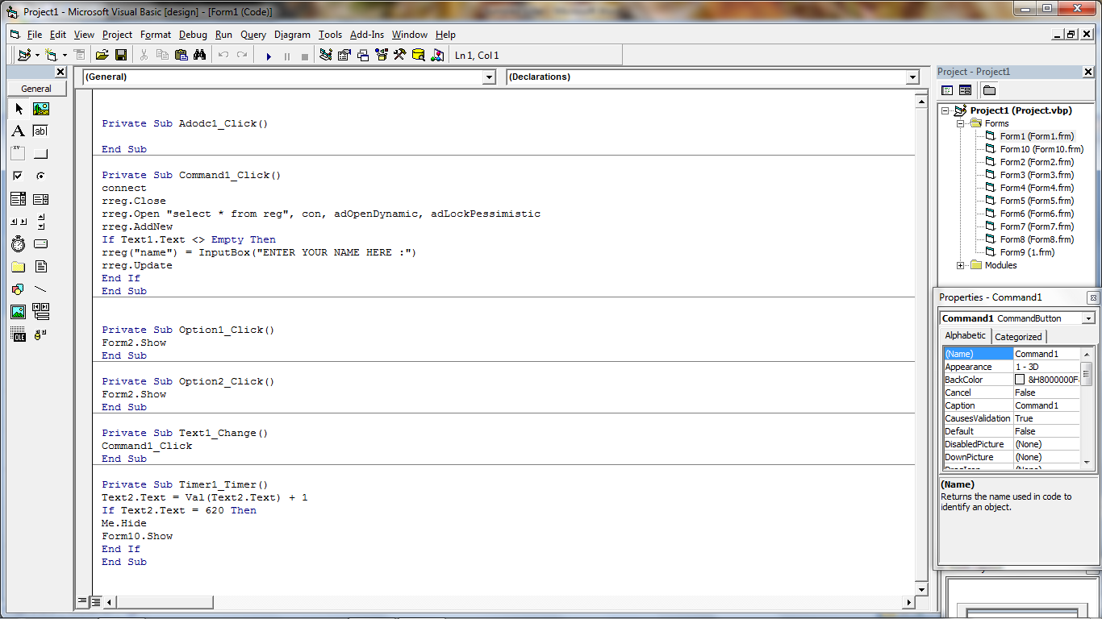

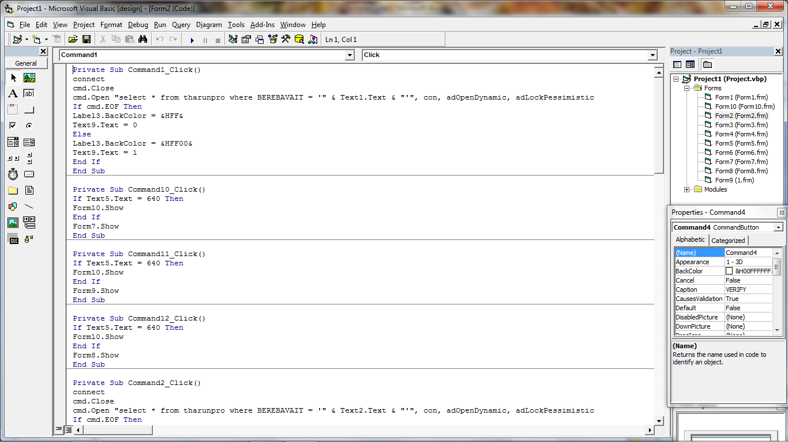

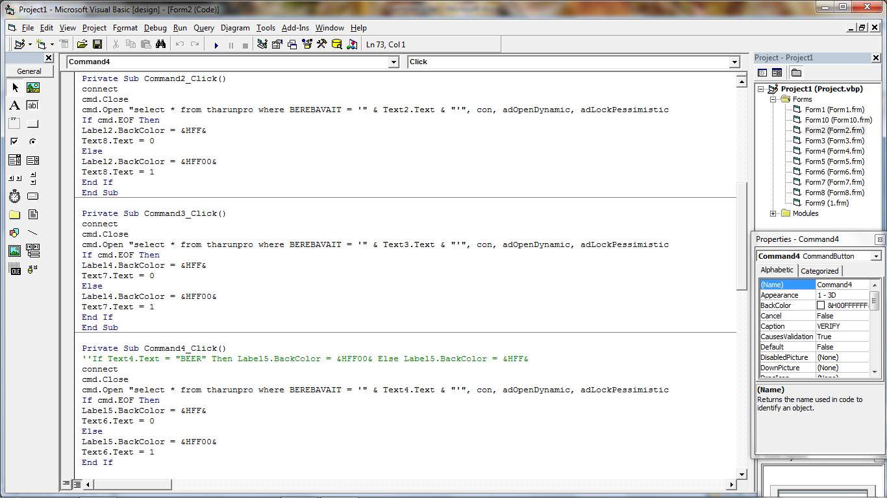

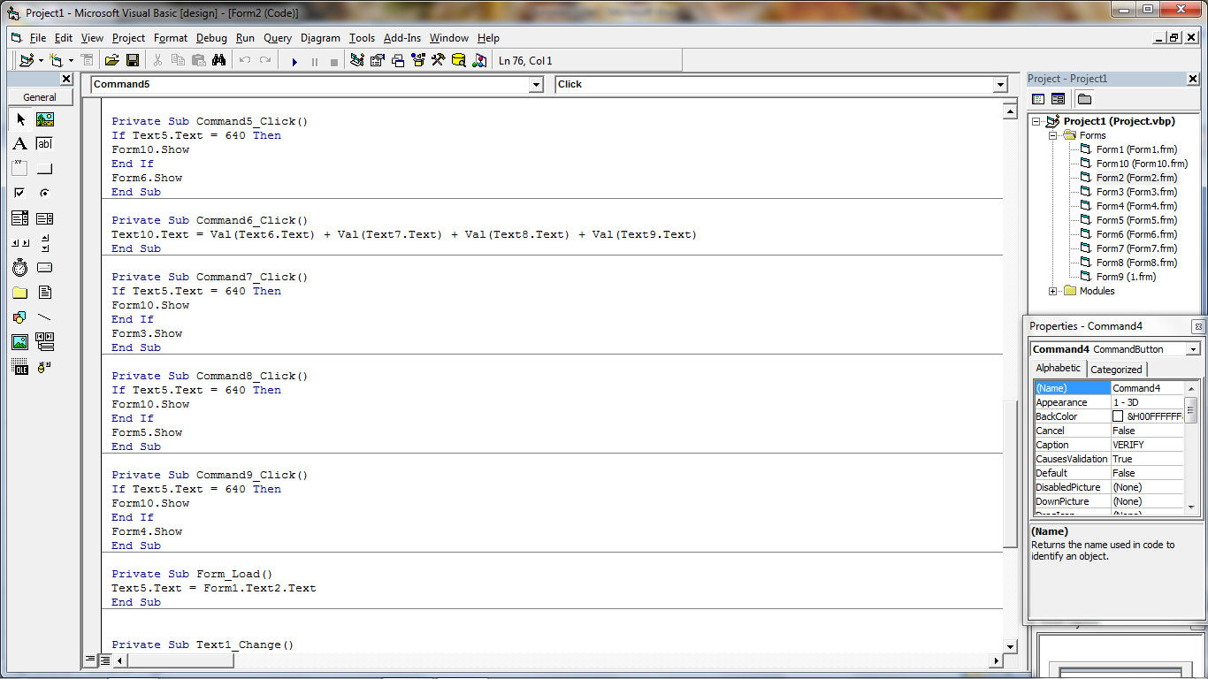

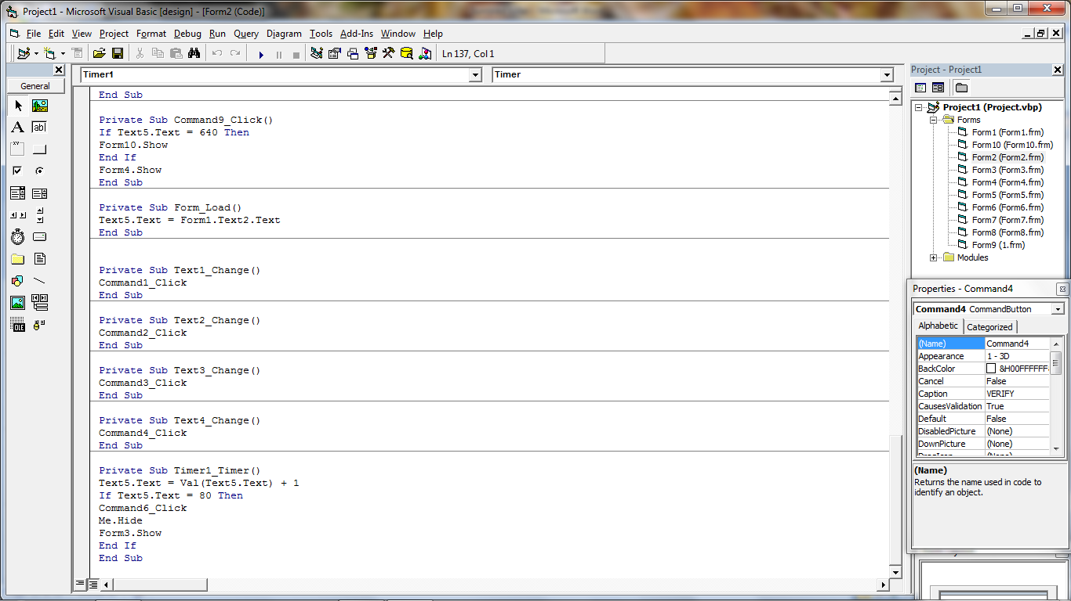

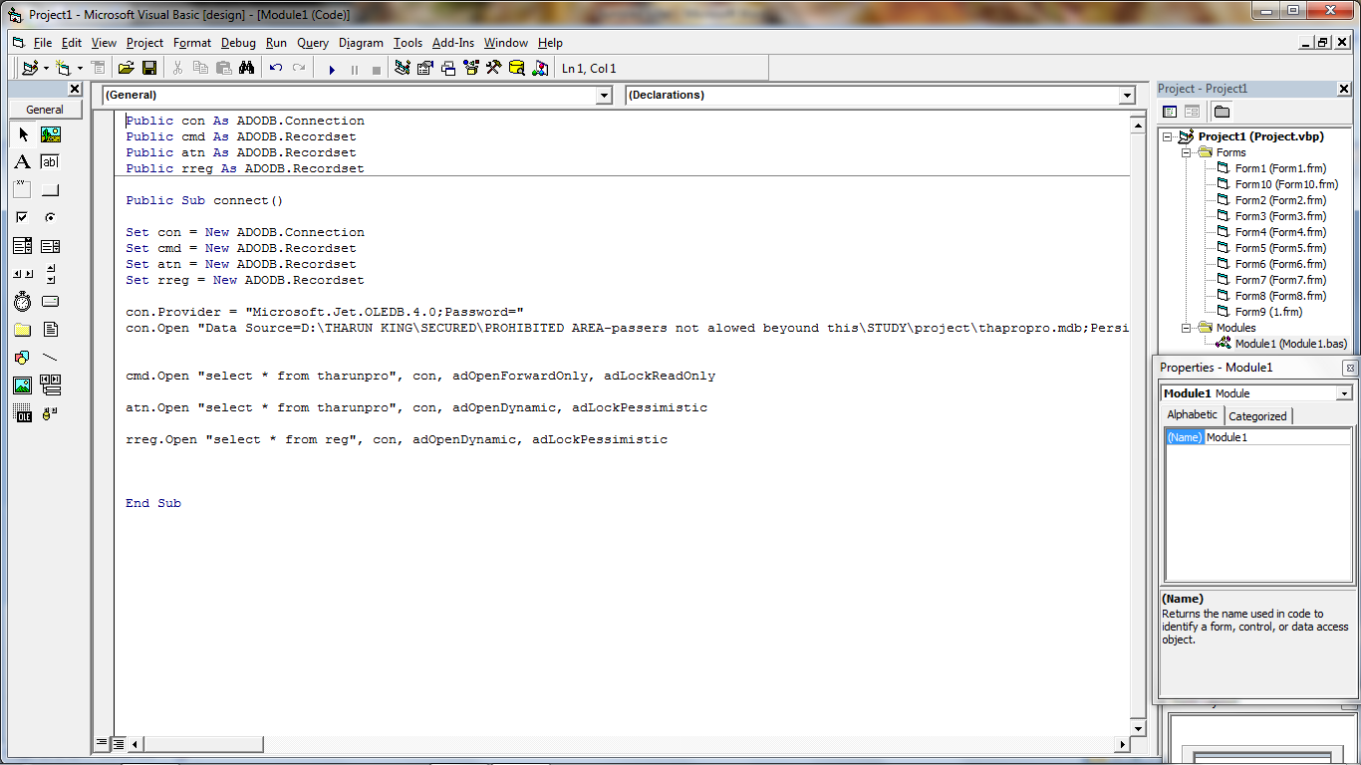

WORKING:

* When the game is executed,
* Form 1 starts loading and T he code is executed step by step.
* It connects our front end to the back end,
* Then it asks the user for his/her name in an input box,
* Which will automatically save his/her name in our database since we have written codes to do it.
* Then form2 gets loaded, user types the answer in the text box ,
* Then the word written in the textbox is checked by the computer by each row of the corresponding column,
* If the typed words matches with any of the word in a row,
* A green color is shown in the label and 1mark is allocated to it,
* If none of the row matches, then red color is shown in the label and 0 marks is allocated.
* Each form is given 80 seconds to answer ,
* After each 80 seconds, form goes on changing,
* After changing of each form, total marks of the previous forms are added with the current form marks..
* And at the end when the time is up, the sum of marks is shown to the user in a textbox named TOTAL,

So in this way, this game is executed …

THANK YOU..